David L. Suddjian
Biological Consulting Services

801 Monterey Avenue, Capitola, CA 95010
Telephone 831· 479· 9603, email dsuddjian@aol.com

Summary of 2007
Marbled Murrelet Monitoring Surveys

In The Santa Cruz Mountains

Prepared for

Command Oil Spill Trustee Council

Prepared by

David L. Suddjian
Biological Consulting Services
801 Monterey Ave., Capitola, CA 95010

February 2008
Final Report
INTRODUCTION

This report presents the results of Marbled Murrelet (Brachyramphus marmoratus, hereafter referred to as “murrelet”) monitoring surveys conducted in 2007 for the Command Oil Spill Trustee Council (COSTC) in the Santa Cruz Mountains at Big Basin Redwoods State Park, Portola Redwoods State Park, Butano State Park, and San Mateo County Memorial Park (Figure 1). These surveys were commissioned to assist the COSTC in restoration planning for potential projects benefiting the murrelet.

Methods

Study Design

Dawn surveys were conducted at five stations in Big Basin, and at two stations each in Portola, Butano, and Memorial (Figure 1). Coverage at Butano, Memorial and one of the Portola stations was begun in 2003 to augment an existing long-term program of monitoring already established at Portola (since 1992) and Big Basin (since 1995). Since 2003 each station in each park has been surveyed three times annually from June to July, with two surveys at each in July. Two additional surveys are conducted at one of the Portola stations so that surveys occur there on three consecutive mornings in late June to continue a pattern of coverage begun at that station in 1992. Total annual surveys for each park are 15 at Big Basin, eight at Portola, and six each at Butano and Memorial.

Location of Survey Stations

Criteria for station placement and the selection of sites were described in Suddjian 2004.

The five stations at Big Basin (“Redwood Meadow”, “100 Acre Woods”, “Blooms Creek”, “Huckleberry”, and “Sempervirens”) were established in 1995 in a dispersed array in the upper watershed of the East Fork of Waddell Creek (Figure 2). “Redwood Meadow” station is at the meadow near the beginning of the Redwood Trail. “100 Acre Woods” station is on the North Escape Road at that road’s northern crossing of Opal Creek. “Blooms Creek” station is along East Ridge Trail east of Blooms Creek Campground. “Huckleberry” station is near site #17 in the tent cabins area of Huckleberry Campground. “Sempervirens” station is east of the Sempervirens Reservoir access road, midway between the reservoir and Sky Meadow Road Road.

At Portola (Figure 3) the “Peters Creek Bridge” station (established in 1992) is located on the bridge adjacent to the park’s main campground. “Iverson” station (established in 2003) is located where Iverson Trail crosses Pescadero Creek west of park headquarters (Figure 3).

At Butano (Figure 4), “Ben Ries” station (established in 2003) is on the main park road 50 meters before the road enters Ben Ries Campground, adjacent to campsite #1. “Little Butano Creek” station (established in 2003) is at a large landslide along a park service road that begins at the entrance to the campground.

At Memorial (Figure 5), “Sequoia” station (established in 2003) is in the Sequoia Flat Campground where the main camp road enters the “D” section of the camp, adjacent to campsite #D1. “Memorial” station (established in 2003) is at Pescadero Creek adjacent to the Tan Oak Flat Picnic Area, at the site of the “swimming pool” that was formerly created seasonally in the creek.

Dawn Murrelet Surveys

Dawn murrelet surveys followed the standard protocol for audio-visual surveys in forests (Pacific Seabird Group 2003). David Suddjian conducted all the surveys. In addition to the murrelet survey data, all bird species detected were recorded (noting initial time, estimates of numbers, and other pertinent information), and two unlimited distance point counts were conducted during each dawn survey (Appendix 1). The point counts lasted 10 minutes and began at 0-5 minutes and 45 minutes after sunrise. Additional details of observations of Common Ravens (Corvus corax) and raptors (direction, distance, behavior, etc.), and a best estimate of the maximum number of Steller’s Jays (Cyanocitta stelleri) noted during each survey were also recorded.

Seasonal Timing of Coverage

Survey dates for each park in 2007 are given on Table 1. An effort was made to schedule coverage at each station on dates close to survey dates of previous years.

Additional Information on Murrelet Occurrence at Big Basin

Appendix 2 presents a summary of survey results from the Redwood Meadow / Park Headquarters parking lot of Big Basin. A total of 203 surveys following the same methods as those of this study have been completed at this site since 1991, representing the longest unbroken series of data for murrelets from any site in the Santa Cruz Mountains, and offering an opportunity to examine longer-term trends. In 2006 Suddjian conducted 14 additional surveys at the Redwood Meadow / Park Headquarters parking lot area from April 19 to July 29, in addition to the three for the COSTC contract.

Appendix 3 presents a summary of results from a USGS Breeding Bird Survey (BBS) route sampled by Suddjian from 1992 to 2007 that begins at Big Basin. While the BBS method is not specifically designed for monitoring murrelets at forest sites, it does provide a repeated measure of activity, and coverage for the BBS at Big Basin was contemporaneous with the other monitoring efforts presented in this report.

Results

Marbled Murrelet

Dawn flight activity in 2007 is characterized below for each park. Subjective descriptors of “low, “moderate,” and “high” activity refer generally to total detection counts in the range of 0-10 detections, 11-50 detections, and >50 detections, respectively. Results of the 2007 murrelet surveys are shown on Table 1. Tables 2 and 3 compare annual average activity at each station and park.

Big Basin Redwoods State Park

Activity remained very low in 2007 compared to the park’s known history of high activity, continuing the pattern of the most recent years (Suddjian 2003a, 2003b, 2004, 2005a, 2005c, 2008) (Table 2, Figures 6 and 7). The 15 surveys produced 71 total detections and just 10 detections of below canopy flights. Six surveys (38%) had no detections at all. As for most recent years, there was no peak in activity during July. There were no detections of particular behavioral interest.

The area around “Redwood Meadow” remained a general hub for murrelet flight activity in the East Fork Waddell watershed. Surveys at “Redwood Meadow” in 2007 produced 69% of all detections recorded in Big Basin, and 80% of all below canopy detections. Activity levels ranged from low to moderate (9-29 detections), with four detections of below canopy flights on two surveys but none on the third (Table 1). Although extensive circling behavior was observed, along with detections of one to two murrelets flying low over the meadow and adjacent Opal Creek, none of the detections observed in 2007 were strongly suggestive of birds visiting active nests.

Activity at “100 Acre Woods” was low (0-9 detections), with activity recorded on only one of three surveys, and no below canopy flights (Table 1). Seven of the nine detections on June 18 were more than 100 meters away from the station, and the activity was oriented to the south, west and northwest.

Activity at “Huckleberry” was low (1-3 detections), but detections were recorded on all three surveys for the second year in a row since 1998, and single below canopy flights were noted on two mornings (Table 1). All of the six total detections involved murrelets flying along the Sempervirens drainage, oriented to the southwest and west of the station, and mostly more than 200 meters from the station. The two detections of below canopy flights were of single birds apparently arcing down the canyon at the upstream extension of flights along the stream corridor.

Activity at “Blooms Creek” was low (0-6 detections), with murrelets noted on two of three surveys, but no detections of below canopy flights (Table 1). Six of seven total detections were oriented to the west or northwest, and all were more than 100 m from the station. Several clearly involved murrelets flying east over Blooms Creek toward the direction of the station, then turning back away to the west. One detection of three murrelets flying west very high (2.4 canopy) over the vicinity of the station was the only evidence that murrelets had flown to areas upstream of the station. No occupied site detections have been recorded at “Blooms Creek” since July 2001.

“Sempervirens” had no detections on any of the surveys (Table 1). There have been no detections on any of the 18 surveys at “Sempervirens” since activity was last noted there in July 2001.

Trends at Big Basin

Activity levels have remained relatively very low since 2002, following a major drop in activity from levels of the mid-1990s (Table 2; Figures 6 and 7). The long-term decline was highly significant for total detections (r² = 0.831, p = 0.0001) and occupied site detections (r² = 0.709, p = 0.0011) (Figures 6 and 7). Each station individually exhibited the same general pattern of a decline from relative high activity in the beginning years of monitoring to relative low activity in recent years (Figure 8). Data collected in 2007 from the more extensive series of surveys at Redwood Meadow (Appendix 2) and from the BBS route (Appendix 3) continued to match the pattern of decline documented by this study.

Portola Redwoods State Park

Overall activity at Portola in 2007 was up slightly from 2006, but remained considerably lower than in 2003-2004 (Table 2, Figures 11 and 13). The number of occupied site behaviors decreased from 2006, and remained much lower than in 2003-2004 (Figure 12). There were no observations of particular behavioral interest during any of the Portola surveys.

Activity at “Peters Creek Bridge” was moderate on four surveys (13-34 detections), and high on one survey (53 detections; Table 1). Just four below canopy flights were recorded over the five surveys. Patterns of activity around the station were similar to prior years, with detections in varied directions and extensive circling over the area.

Activity at “Iverson” was low to barely moderate (6-11 detections), with two detections of below canopy flights on one of three surveys (Table 1). This relatively low level of activity contrasted strongly with that noted in 2003 and 2004 (Suddjian 2004 and 2005a), when activity at “Iverson” had been among the highest of any station in this study (Table 2, Figure 13).

Trends at Portola

Three Consecutive Mornings at Peters Creek Bridge. The only long term comparison available for Portola is for the surveys conducted on three consecutive mornings in late June at “Peters Creek Bridge” (Table 3). Activity in 2007 increased slightly from 2006, but compared to prior years, activity has been relatively low since 2002 (Table 3, Figure 9). Linear regression on average total detections over the whole period of 1992-2007 showed a significant declining trend (r² = 0.434, P = 0.0099; Figure 10). The declining trend for occupied site detections was non-significant over the whole period of 1992-2007 (P = 0.113), but was significant from 1995 onwards (r² = 0.673, p = 0.0034).

Entire Season. The five-year period 2003-2007 showed a marginally significant decline in total detections (r² = 0.552, P = 0.075), and a significant decline in occupied site detections (r² = 0.704, P = 0.038). The decrease is shown on Figures 11 and 12.

Butano State Park

Overall activity at Butano in 2007 was nearly the same as in 2006, and was similar to most years in the five year study period (Table 2, Figures 11 and 13). The number of occupied site behaviors increased slightly from 2005-2006, but remained much lower than in 2004 (Figure 12). There were no observations of particular behavioral interest during any of the Butano surveys, but surveys at Little Butano Creek station recorded intense activity by multiple birds.

Activity at “Ben Ries” ranged from low to moderate (4-26 detections), with a single below canopy flight recorded on one survey (Table 1). As in prior years (Suddjian 2004, 2005a, 2005b, 2008), much of the flight activity was oriented toward Little Butano Creek or up the canyon to the east, and included detections of birds moving up or down the drainage. There were also a small number of detections close to the station and over the adjacent campground. The lone below canopy diction was of two murrelets flying in the corridor over the main park road.

Activity at “Little Butano Creek” was moderate to high (15-85 detections), with 2-8 occupied site detections noted on each survey (Table 1). Activity at this station averaged the highest for any station in the study for the third year in a row, with 85 detections on July 24 being the most recorded on any survey in 2007. As in prior years, each survey recorded extensive movement by murrelets flying up and down the drainage, and circling over the canyon in the vicinity of the station. There were no observations of particular behavioral interest.

Trends at Butano

The five-year period 2003-2007 showed a shallow, non-significant decline for both total detections and occupied site detections (Figures 11 and 12).

San Mateo County Memorial Park

Overall activity at Memorial Park in 2007 decreased from 2006, and was the lowest recorded in the park over the five-year period (Table 2, Figures 11 and 13). As in prior years, the number of occupied site behaviors was very low (Figure 12). There were no observations of particular behavioral interest during any of the Memorial surveys.

“Memorial” had very low activity, with just two detections on one survey (Table 1). Both were distant to the southeast.

“Sequoia” had no detections on the June survey, but low to moderate activity (7-19 detections) on the two July surveys (Table 1). Several detections were of murrelets circling broadly over the area. The lone occupied site detection was of two birds circling below canopy over the station

Trends at Memorial

The trend for the five-year period of 2003-2007 shows a non-significant decline for both total detections and occupied site detections (Figures 11 and 12).

CORVIDS

Counts of Steller’s Jay and Common Raven from the dawn surveys at each station are given on Table 4. General summaries of numbers and activities around the murrelet survey station are given below.

Big Basin Redwoods State Park

Steller’s Jay

Steller’s Jay was detected on all surveys at all stations. The pattern of relative abundance among stations closely matched that of prior years (Suddjian 2003a, 2004, 2005a, 2005b, 2008), with highest abundance correlated with the proximity to campgrounds (Table 4). Overall jay abundance recorded during the murrelet surveys increased slightly in 2007, and was slightly higher than in prior years; however it was very near to that of 2001, 2004 and 2006 (Figure 14).

Common Raven

Common Raven was detected on all surveys at all stations. Counts ranged from 3-6 per station (Table 4). Overall raven abundance recorded during the murrelet surveys increased in 2007, and was somewhat higher than in prior years; however it was near to that of 2002 (Figure 15). Territorial pairs resided near each of the stations, and nesting productivity was high. Observations made across the season indicated about 11 pairs of ravens were residing in the park in the watersheds of Opal, Blooms, and Sempervirens/Union creeks, plus some additional singletons.

“Redwood Meadow” had a pair of adults that focused its activities around the park store and headquarters area, plus others that were heard in the distance to the N, west and south. Another pair was north of the meadow at the south end of Opal Creek Picnic Area. The latter pair nested near Gazos Creek Road about 0.2 mile east of Opal Creek, and fledged three juveniles by July 6. A pair of ravens resided at “100 Acre Woods”, fledgling two juveniles by July 17 from a nest that was likely north of the station. At “Blooms Creek” a pair of ravens nested northeast of the station and fledged at two juveniles by July 6. Additional adults were heard to the west. At “Huckleberry” one pair of adults nested to the southeast of the campground and fledged three juveniles by July 3. Another pair nested west or northwest of the campground and fledged two juveniles by July 18. At “Sempervirens” a pair nested near the reservoir and fledged two juveniles by July 21.

No exceptional roosts or other concentrations were noted in the study area in 2007.

Portola Redwoods State Park

Steller’s Jay

Steller’s Jay was detected on all surveys at both stations, with somewhat more tallied at “Peters Creek Bridge” (at the edge of the campground) than at “Iverson” (Table 4). Overall jay abundance recorded during the murrelet surveys increased slightly, and was similar to that of 2003-2004 (Figure 14).

Common Raven

Members of a pair, joined in July by their fledglings, were noted on each survey at “Peter’s Creek Bridge”, and singles recorded on two surveys at “Iverson” were likely part of the same pair (Table 4). This pair nested along Iverson Trail east of Tiptoe Falls, fledging two juveniles on July 11. This was apparently the only pair residing in 2007 in the area of the park covered by this study. A pair with three juveniles at the campground on August 21 may have been a different family that was not present earlier in the season.

A single adult raven flying north-northeast high over “Peter’s Creek Bridge” on July 12 was the only “non-local” raven seen during the dawn surveys. Small flocks of such “commuters” were also noted in 2002, 2003 and 2005 (Suddjian 2003a, 2003b, 2004, 2005c).

Butano State Park

Steller’s Jay

Steller’s Jay was detected on all surveys at both stations, with more jays recorded at “Ben Ries” (beside the campground) than at “Little Butano Creek” (Table 4). Overall jay abundance recorded during the murrelet surveys decreased slightly in 2007, reaching a new low for the five-year period (Figure 14).

Common Raven

A pair nesting northeast of the campground entrance was detected on each survey at “Ben Ries”, fledging two juveniles by July 1. This pair and, later, the family ranged down the canyon regularly to visit the campground and adjacent areas. A different pair (sometimes with an extra adult) was noted on the first two dawn survey at “Little Butano Creek” station, with a nest site possibly north or north east of that station. This pair may have been same as seen at and near the campground on July 23-24, accompanied by three juveniles. These two successfully nesting pairs, plus the extra adult, were apparently the only ravens nesting in 2007 in the part of the park encompassed by this study.

San Mateo County Memorial Park

Steller’s Jay

Steller’s Jay was detected on all surveys at both stations, with high numbers at Sequoia Flat (Table 4). Jay abundance increased after a dip in 2006, and jays remained considerably more abundant at Memorial County Park than the other parks (Figure 14).

Common Raven

Common Ravens were encountered on each survey at both stations, and multiple pairs and families present in the park in 2007 (Table 4). Raven numbers recorded during the dawn surveys reached a new high in 2007 (Figure 15). At least six pairs nested in or near the park in 2007, with at least five pairs fledging young. Juveniles were first noted at “Sequoia Flat” on June 14 and at “Memorial” on July 9. The nest at Sequoia Flat campground was located in or adjacent to the “A” section of the camp. Adults of other pairs also visited “Sequoia Flat” campground.

Five adult ravens west high over “Memorial” station on June 13, apparently leaving a roost to head down the Pescadero Creek canyon. These were the only obvious “non-local” ravens recorded in the park in 2007.

RAPTORS

Big Basin Redwoods State Park

An adult Sharp-shinned Hawk (Accipiter striatus) was calling east of “Redwood Meadow” on June 17.

Adult Cooper’s Hawks (A. cooperi) were calling south of “Sempervirens” on July 7 and at “Huckleberry” on July 18. One was seen at the latter site on August 17, as well. No fledglings were encountered this year.

Red-shouldered Hawk (Buteo lineatus) detections continued to increase, with 24 occurrences recorded at varied locations from June to July. They were recorded at all five murrelet survey stations for the second year in a row (Suddjian 2008). Extensive field surveys by Suddjian for this study and other research in the park produced an estimate of nine breeding pairs in the East Fork Waddell watershed in the 2007 breeding season, up from a record seven pairs in 2006. Nesting was confirmed by the presence of juveniles at four locations.

Barn Owl (Tyto alba), Western Screech-Owl (Megascops kennicottii), Northern Pygmy-Owl (Glaucidium gnoma), and Northern Saw-whet Owl (Aegolius acadicus) were heard in the study area this year.

Portola Redwoods State Park

Two pairs Red-shouldered Hawks, noted on multiple dates, resided in the area of the park visited for these surveys. One pair nested in an old growth redwood along Pescadero Creek at Sequoia Nature Trail, fledging young shortly after June 28. Another pair was north of there, near the ranger residence #1 along Portola State Park Road. An additional bird west of “Iverson” on June 26 was probably not a member of these pairs.

An adult Red-tailed Hawk (B. jamaicensis) soaring over the campground on June 27 was the first occurrence of that species noted in the portion of the park covered by this study.

Barn Owl, Western Screech-Owl, and Northern Pygmy-Owl were noted in the study area.

Butano State Park

An Osprey (Pandion haliaetus) flew coastward down the Little Butano Creek canyon near the campground on June 10.

A pair of Sharp-shinned Hawks nested at the north margin of the walk-in area of the campground. The adults were heard repeatedly in June and early July, and two begging juveniles had fledged by July 22.

An adult Cooper’s Hawks was calling just east of the campground on June 12. None were noted subsequently until August 8, when an adult was at the campground and a juvenile was begging east of the campground.

A pair of Red-shouldered Hawks resided tot eh south and southwest of the campground, sometimes extending up the canyon into the campground and vicinity. None were detected upstream of the campground this year.

Barn Owl, Western Screech-Owl and Northern Pygmy-Owl were heard around the campground this year.

San Mateo County Memorial Park

An adult male Sharp-shinned Hawk was at “Memorial” station on July 28.

Red-shouldered Hawks were numerous in and adjacent to Memorial Park in 2007. There were at least three or four pairs at this park and surroundings in June and July, although it was difficult to sort out how many individuals or pairs were present among many detections. Five to seven individuals were recorded at and adjacent to Sequoia Flat Campground along on July 25. Nesting was confirmed by the presence of juveniles beginning July 10, with young noted near both murrelet survey stations.

A pair of Peregrine Falcons was present near the south edge of the park on June 13-14. A family group of fledglings tended by the adult male had been observed in the park in July on 2005 and 2006, but no young were evident in 2007. Observations of the adults in June included a prey exchange that took place in the vicinity of Wurr Road south of Sequoia Flat campground on June 14. The initial detection of the calls of the male on June 13 came from southeast of the “Memorial” station, suggesting a nest site in that direction (as in prior years). The presence of the adults and the prey exchange documented continued occupancy of the territory in 2007, but it appeared that any nesting attempt failed.

Five species of owls were detected from Memorial Park in 2007: Barn Owl, Western Screech-Owl, Great Horned Owl, Northern Pygmy-Owl, and Northern Saw-whet Owl. The Great Horned, unusual for this study, was calling some distance north of Sequoia Flat Campground on June 14. The other four species were all detected in the campground, including a family group of Saw-whets on July 24.

Discussion

In 2007 Marbled Murrelet activity levels increased somewhat at Portola, remained the same at Butano, and decreased at Big Basin and Memorial (Figures 11). However, the increase in total activity at Portola was paired with a decrease in detections of below canopy flights (Figure 12). Butano had the highest activity for the fourth year in a row, followed by Portola, with Big Basin and Memorial similarly low, ranking in third and fourth place, respectively (Figure 11). Activity levels in 2007 for all parks combined were very similar to 2006, but with a decrease in below-canopy flights (Figure 16). The low incidence of occupied site behavior recorded by this study in recent years is alarming.

The five-year period had declining trends for both total detections and occupied site behaviors for all parks combined, with the trend for occupied site detections being statistically significant (r² = 0.622, p = 0.057). Declining trends for the two areas with long-term data sets – Big Basin Park and Peter’s Creek Bridge in Portola – continued to be highly significant. Declining trends for the five-year data set at Portola covering this study were also significant.

Among the suite of predators and other factors affecting the Santa Cruz Mountains population of Marbled Murrelets, the region’s burgeoning breeding population of Red-shouldered Hawks merits more attention and concern than it has so far be afforded. Attention and management actions are rightly being directed toward the two corvids in the parks, but consideration should be also given to the hawk. The Red-shouldered Hawk is a documented murrelet predator (Nelson 1997); indeed, one was seen taking an adult from the nest adjacent to Portola State Park in 1996 (E. Burkett, pers. comm.). It was formerly mostly absent from extensive forest areas of the Santa Cruz Mountains, especially old growth forest. But since the 1990s it has expanded its local range to include essentially all of the forested regions of the Santa Cruz Mountains, and it is now a relatively common diurnal raptor in old growth forests in the area. In some parks it is the most common diurnal raptor. The local population increase has been documented by several sources, including this study. The USGS BBS route that encompasses the region of this study (route CA Pescadero #319; see Appendix 3) has recorded a highly significant increasing trend for Red-shouldered Hawk for the period 1992-2007 (p = 0.001). In 2007 there were at least fifteen pairs in the areas of the four parks encompassed by this study, and the species was recorded during dawn surveys at all but one murrelet survey station (Appendix 1). The only station without detections of the hawk in 2007 has had the species present in 2006 and other years.

Literature Cited

Nelson, S. K. 1997. Marbled Murrelet (Brachyramphus marmoratus). No. 276 in The birds of North America (A. Poole and F. Gill, Eds.) Acad. Of Nat. Sci., Philadelphia, Pennsylvania, and the Amer. Orn. Union, Washington D.C.

Pacific Seabird Group. 2003. Methods for surveying Marbled Murrelets in forests: a revised protocol for land management and research. Marbled Murrelet Technical Committee. Unpubl. report dated 6 January, 2003.

Suddjian, D. L. 2001. 2001 Marbled Murrelet Monitoring Surveys at Big Basin and Portola State Parks. Unpubl. report. Prepared for the California Dept. of Fish and Game.

Suddjian, D. L. 2003a. Summary of 2002 Marbled Murrelet monitoring surveys
at Big Basin and Portola State Parks. Unpubl. report. Prepared for the California Dept. of Fish and Game.

Suddjian, D. L. 2003b. Summary of 2003 Department of Fish and Game Marbled Murrelet Monitoring Surveys At Big Basin and Portola Redwoods State Parks Unpubl. report prepared for the California Dept. of Fish and Game.

Suddjian, D. L. 2004. Summary of 2003 Marbled Murrelet Surveys in the Santa Cruz Mountains. Unpubl. report prepared for Command Oil Spill Trustee Council.

Suddjian, D. L. 2005a. Summary of 2004 Marbled Murrelet Surveys in the Santa Cruz Mountains. Unpubl. report prepared for Command Oil Spill Trustee Council.

Suddjian D. L. 2005b. Summary of 2004 Corvid Monitoring Surveys in the Santa Cruz Mountains. Unpubl. report prepared for Command Oil Spill Trustee Council.

Suddjian, D. L. 2005c. Summary of 2005 Marbled Murrelet Surveys in the Santa Cruz Mountains. Unpubl. report prepared for Command Oil Spill Trustee Council.

Suddjian, D. L. 2008. Summary of 2006 Marbled Murrelet Surveys in the Santa Cruz Mountains. Unpubl. report prepared for Command Oil Spill Trustee Council.
Table 1. Summary of dawn murrelet surveys conducted at each park in 2007.

Station Date Obs. Cloud Precip. Total # OB¹
Cover # Dets. Dets.

Big Basin

Redwood Meadow 17 June 07 DLS 50-100% Fog 29 4
Redwood Meadow 4 July 07 DLS 0% None 11 4
Redwood Meadow 19 July 07 DLS 0-15% None 9 0

100 Acre Woods 18 June 07 DLS 0% None 9 0
100 Acre Woods 5 July 07 DLS 0-20% None 0 0
100 Acre Woods 17 July 07 DLS 0% None 0 0

Blooms Creek 21 June 07 DLS 0% None 1 0
Blooms Creek 6 July 07 DLS 0% None 0 0
Blooms Creek 20 July 07 DLS 0% None 6 0

Huckleberry 20 June 07 DLS 60-100% Fog 1 0
Huckleberry 3 July 07 DLS 0% None 2 1
Huckleberry 18 July 07 DLS 100% Fog/Driz. 3 1

Sempervirens 19 June 07 DLS 100% Fog 0 0
Sempervirens 7 July 07 DLS 0% None 0 0
Sempervirens 21 July 07 DLS 0-100% Fog 0 0

Portola

Iverson 26 June 07 DLS 0-100% Fog 6 0
Iverson 11 July 07 DLS 100% Fog 11 2
Iverson 26 July 07 DLS 100% Fog 9 0

Peters Creek Bridge 27 June 07 DLS 0-100% Fog. 24 0
Peters Creek Bridge 28 June 07² DLS 0% None 13 0
Peters Creek Bridge 29 June 07² DLS 100% Fog 34 2
Peters Creek Bridge 12 July 07 DLS 50-100% Fog 53 1
Peters Creek Bridge 27 July 07 DLS 100% Fog 29 1

Table 1, continued

Station Date Obs. Cloud Precip. Total # OB¹
Cover # Dets. Dets.

Butano

Ben Ries 10 June 07 DLS 70-100% Fog 26 1
Ben Ries 1 July 07 DLS 30-100% Fog 4 0
Ben Ries 23 July 07 DLS 75-100% Fog 8 0

Little Butano Creek 12 June 07 DLS 0% None 15 8
Little Butano Creek 2 July 07 DLS 0% None 39 7
Little Butano Creek 24 July 07 DLS 100% Fog 85 2

Memorial

Memorial 13 June 07 DLS 0% None 2 0
Memorial 9 July 07 DLS 100% Fog 0 0
Memorial 28 July 07 DLS 50-100% Fog 0 0

Sequoia 14 June 07 DLS 0% None 0 0
Sequoia 10 July 07 DLS 100% Fog 19 0
Sequoia 25 July 07 DLS 100% Fog/Driz. 7 1

- OB = detections with “occupied site” behavior (i.e., below canopy flight or tree interactions).
- Two extra surveys were done at Peters Creek Bridge as part of the annual monitoring pattern established for this station.

Table 2. Comparison of murrelet activity levels between years at each park from 1995-2007.¹

All Detections Occupied Site Detections
Station Year N Avg # S.D. Avg # S.D.
Dets. Dets.

Big Basin

Redwood Meadow 1995 4 177.0 102.3 64.0 69.5
1996 4 97.0 19.0 27.5 11.6
1998 4 92.3 54.0 33.5 31.8
2001 3 86.3 125.5 8.0 7.0
2002 3 18.7 15.9 1.3 1.5
2003 3 16.3 5.7 1.3 1.5
2004 3 17.0 14.0 2.3 0.6
2005 3 14.0 6.1 1.3 1.5
2006 3 18.3 9.7 9.0 5.2
2007 3 16.3 11.0 2.7 2.3

100 Acre Woods 1995 4 25.3 20.7 9.0 9.4
1996 4 9.5 7.1 2.0 2.4
1998 4 5.0 4.4 3.7 3.5
2001 3 3.7 4.6 0.3 0.6
2002 3 2.7 4.6 0.0 0.0
2003 3 7.0 11.3 2.3 4.5
2004 3 7.0 10.4 0.0 0.0
2005 3 1.0 1.7 0.0 0.0
2006 3 8.0 11.1 3.0 5.2
2007 3 3.0 5.2 0.0 0.0

Blooms Creek 1995 4 44.8 42.5 1.5 2.4
1996 4 44.8 27.0 1.8 2.2
1998 4 15.0 14.5 1.0 1.4
2001 3 23.0 4.4 3.0 5.2
2002 3 0.7 1.2 0.0 0.0
2003 3 2.7 1.5 0.0 0.0
2004 3 1.3 1.5 0.0 0.0
2005 3 4.0 3.0 0.0 0.0
2006 3 3.0 4.4 0.0 0.0
2007 3 2.3 3.2 0.0 0.0

Huckleberry 1995 4 24.3 18.1 7.5 9.3
1996 4 23.3 25.1 5.5 9.7
1998 4 14.0 9.9 1.0 0.8
2001 3 4.3 3.8 0.0 0.0
2002 3 0.0 0.0 0.0 0.0
2003 3 3.0 2.6 0.7 1.2
2004 3 0.3 0.6 0.0 0.0
2005 3 1.0 1.7 0.0 0.0
2006 3 6.0 3.5 0.3 0.6
2007 3 2.0 1.0 0.7 0.6

Table 2, continued.

All Detections Occupied Site Detections
Station Year N Avg # S.D. Avg # S.D.
Dets. Dets.

Big Basin, continued

Sempervirens 1995 4 1.3 1.9 0.3 0.5
1996 4 4.8 7.5 0.0 0.0
1998 4 5.3 8.6 0.3 0.5
2001 3 1.0 1.7 0.0 0.0
2002 3 0.0 0.0 0.0 0.0
2003 3 0.0 0.0 0.0 0.0
2004 3 0.0 0.0 0.0 0.0
2005 3 0.0 0.0 0.0 0.0
2006 3 0.0 0.0 0.0 0.0
2007 3 0.0 0.0 0.0 0.0

All Big Basin 1995 20 54.5 78.8 16.5 37.4
Stations Combined 1996 20 35.9 38.4 7.4 12.2
1998 20 27.4 41.9 8.1 18.8
2001 15 23.7 58.1 2.3 4.6
2002 15 4.4 9.7 0.3 0.8
2003 15 5.8 7.7 0.9 1.9
2004 15 5.1 9.4 0.5 1.0
2005 15 4.0 6.0 0.3 0.8
2006 15 7.1 8.8 2.5 4.5
2007 15 4.7 7.7 1.9 1.4

Portola

Peters Creek Bridge 2003 5 33.2 16.9 6.0 6.4
2004 5 35.6 22.2 4.4 3.4
2005 5 18.0 5.9 0.2 0.4
2006 5 18.6 4.2 2.4 1.8
2007 5 30.6 14.7 0.8 0.8

Iverson 2003 3 59.3 18.6 28.3 10.7
2004 3 39.3 13.6 9.0 5.3
2005 3 3.7 3.1 0.0 0.0
2006 3 11.7 9.1 1.7 2.9
2007 3 8.7 2.5 0.7 1.2

All Portola 2003 8 43.0 21.1 14.4 13.8
Stations Combined 2004 8 37.0 18.4 6.1 4.5
2005 8 12.6 8.8 0.1 0.4
2006 8 16.0 6.8 2.1 2.1
2007 8 22.4 16.0 0.8 0.9

Table 2, continued.

All Detections Occupied Site Detections
Station Year N Avg # S.D. Avg # S.D.
Dets. Dets.

Butano

Ben Ries 2003 3 23.3 19.0 1.3 2.3
2004 3 48.0 34.0 5.7 6.0
2005 3 13.7 11.9 0.0 0.0
2006 3 11.7 9.6 0.7 1.2
2007 3 12.7 11.7 0.3 0.6

Little Butano Creek 2003 3 34.0 8.2 6.0 8.7
2004 3 68.3 40.4 22.0 14.4
2005 3 26.7 2.5 4.0 5.3
2006 3 48.0 29.9 4.3 4.5
2007 3 46.3 35.6 5.7 3.2

All Butano 2003 6 28.7 14.3 3.7 6.2
Stations Combined 2004 6 58.2 35.2 13.8 13.3
2005 6 20.2 10.5 2.0 4.0
2006 6 29.8 28.1 2.5 3.6
2007 6 29.5 30.0 3.0 3.6

Memorial

Memorial 2003 3 4.3 6.7 0.0 0.0
2004 3 1.0 1.7 0.0 0.0
2005 3 1.3 1.5 0.0 0.0
2006 3 4.7 5.7 0.3 0.6
2007 3 0.7 1.2 0.0 0.0

Sequoia 2003 3 9.7 7.4 0.7 1.2
2004 3 12.3 7.6 1.0 1.0
2005 3 15.3 15.0 0.0 0.0
2006 3 13.7 8.6 0.0 0.0
2007 3 8.7 9.6 0.3 0.6

All Memorial 2003 6 7.0 6.9 0.3 0.8
Stations Combined 2004 6 6.7 7.9 0.5 0.8
2005 6 15.3 15.0 0.0 0.0
2006 6 9.2 8.8 0.2 0.4
2007 6 4.7 7.5 0.2 0.4

1. This table only presents data from CDFG or COSTC sponsored surveys. Results from additional non-CDFG or COSTC sponsored surveys are not shown.

Table 3. Average annual murrelet activity on the three consecutive dawn surveys at “Peters Creek Bridge” station in Portola Redwoods State Park, 1992-2007.¹

All Detections Occupied Site Detections
Station Year N Avg # S.D. Avg # S.D.
Dets. Dets.

Peters Creek Bridge 1992 3 40.7 12.1 4.0 2.6
1993 3 71.3 7.6 3.0 2.6
1994 3 167.3 36.1 8.0 2.0
1995 3 80.0 19.1 17.3 20.5

1998 3 73.7 22.3 18.0 16.5

2001 3 79.0 22.3 19.7 18.8
2002 3 32.3 1.2 2.7 1.5
2003 3 21.3 6.5 1.3 0.6
2004 3 25.3 3.2 2.0 1.0
2005 3 20.3 6.0 0.3 0.6
2006 3 18.0 2.0 2.7 1.5
2007 3 23.7 10.5 0.7 1.2

1. Only data from the surveys on three consecutive mornings in late June or very early July is shown. There is no data available for 1996, 1997, 1999, or 2000.
Table 4. High counts for Steller’s Jay and Common Raven from 10-minute point counts and 2-hour dawn surveys at each park in 2007.

Steller’s Jay Common Raven
Point 2-hour Point 2-hour
Counts Survey Counts Survey

Big Basin
Redwood Meadow 7 9 1 3
100 Acre Woods 7 7 2 4
Bloom’s Creek 7 8 5 5
Huckleberry 30 30 4 6
Sempervirens 4 5 4 4

Portola
Peters Creek Bridge 6 8 4 5
Iverson 5 6 --¹ 1

Butano
Ben Ries 8 8 4 4
Little Butano Creek 4 6 2 3

Memorial
Memorial 4 6 8 9
Sequoia 24 25 3 9

1. A raven was recorded during two surveys, but not during the 10-min. point counts.
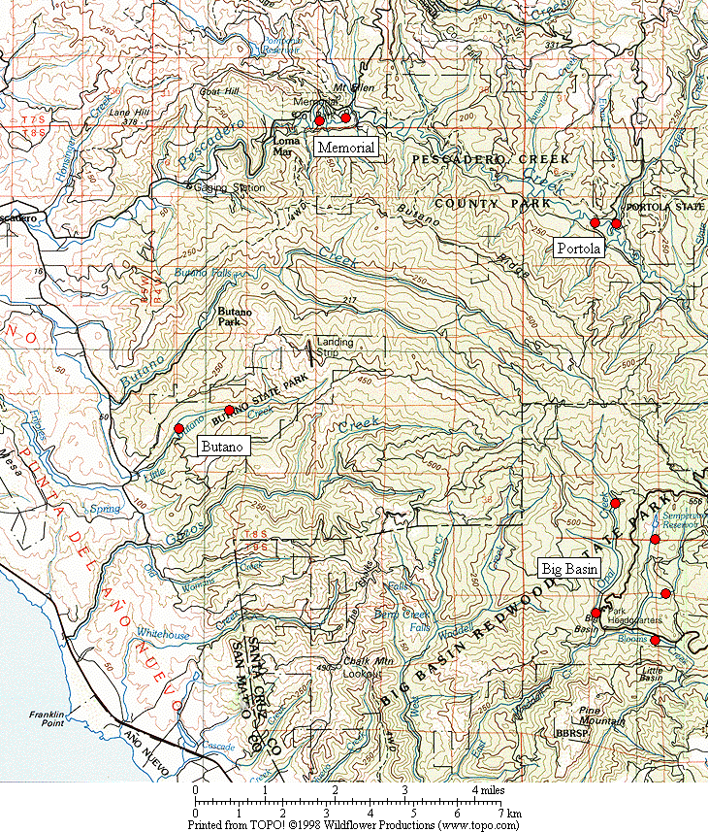

Figure 1. General location of the Marbled Murrelet monitoring stations in the four Santa Cruz Mountains parks.

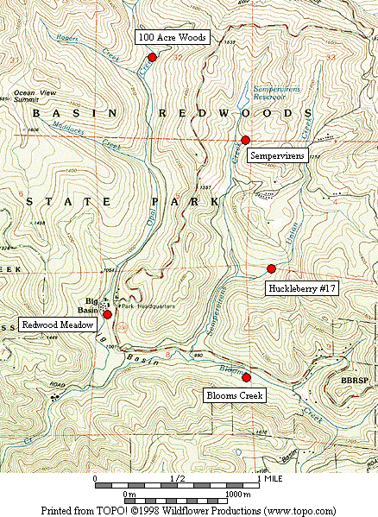

Figure 2. Location of Marbled Murrelet monitoring stations in Big Basin Redwoods State Park.

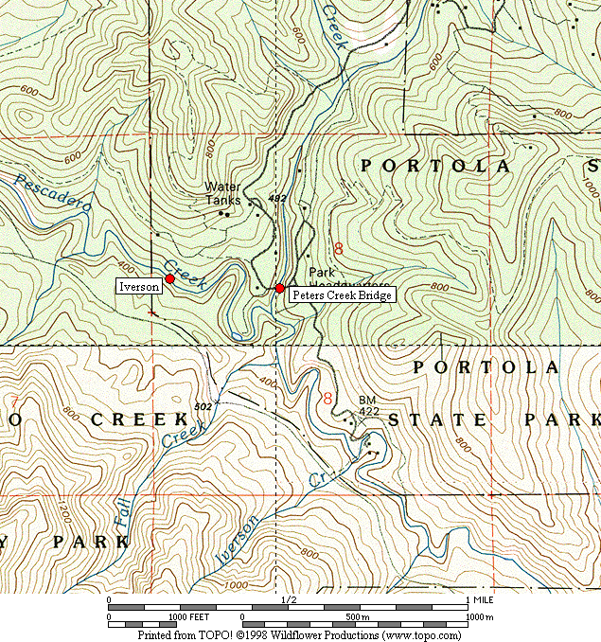

Figure 3. Location of Marbled Murrelet monitoring stations in Portola Redwoods State Park.

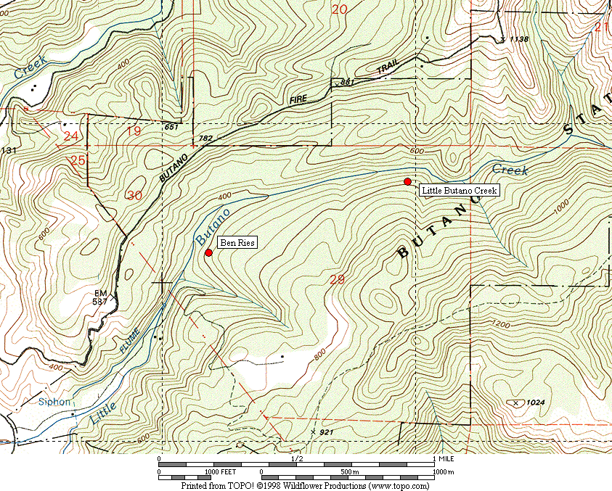

Figure 4. Location of Marbled Murrelet monitoring stations in Butano State Park.

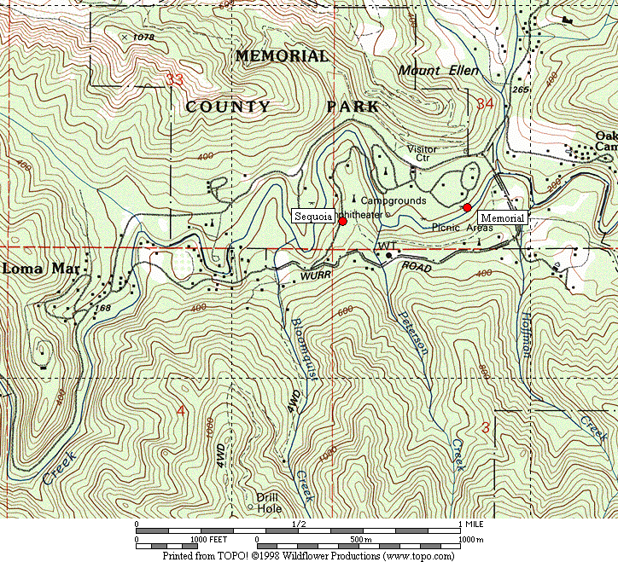

Figure 5. Location of Marbled Murrelet monitoring stations in San Mateo County Memorial Park.

Figure 6. Average murrelet activity on dawn surveys from all five Big Basin stations, 1995-2007. (Note: no data from 1997, 1999 or 2000.)

Figure 7. Average annual murrelet activity at all five Big Basin stations, showing total detections with polynomial regression trend, 1995-2007. (Note: no data from 1997, 1999 or 2000.)

A. “Redwood Meadow” B. “100 Acre Woods”

C. “Blooms Creek” D. “Huckleberry” (Note: no
detections were recorded in 2002)

E. “Sempervirens” (Note: no detections
were recorded in 2002 to 2007)

Figure 8. Annual activity levels (average total detections) at individual Big Basin monitoring stations from 1995 – 2007. (Note: no data for 1997, 1999 or 2000. See table 2 for standard deviations)
Figure 9. Average detections from dawn surveys on three consecutive mornings in late June or early July at “Peters Creek Bridge,” Portola Redwoods State Park, 1992-2007. (Note: no data from 1996, 1997, 1999, or 2000.)

Figure 10. Linear regression on average detections from dawn surveys on three consecutive mornings at “Peters Creek Bridge” in Portola Redwoods State Park, 1992 to 2007. (Note: no data from 1996, 1997, 1999, or 2000.)

Figure 11. Relative levels of Marbled Murrelet activity at each park in 2003 to 2007 using total detections.

Figure 12. Relative levels of Marbled Murrelet activity at each park in 2003 to 2007 using detections with occupied site behavior.

A. “Peters Creek Bridge”, Portola B. “Iverson”, Portola C. “Ben Ries”, Butano

D. “Little Butano Creek”, Butano E. “Memorial”, Memorial F. “Sequoia”, Memorial

Figure 13. Annual activity levels (average total detections) at individual monitoring stations from 2003-2007 at Portola, Butano and Memorial parks. (Note: scales for the y-axis vary; see table 2 for standard deviations)

32

- Individual Parks

- All Parks Combined

Figure 14. Average number of Steller’s Jays (A) per station in each park 2001-2007, and (B) in all parks combined 2003-2006. (Notes: Data from dawn murrelet surveys, using maximum count per year for each station. Jay numbers from 10-minute point counts. Only Big Basin stations were surveyed in 2001-2002).

A. Individual Parks

B. All Parks Combined

Figure 15. Average number of Common Ravens (A) per station in each park 2001-2007, and (B) in all parks combined 2003-2006. (Notes: Data from dawn murrelet surveys, using maximum count per year for each station. Raven numbers from 2-hour surveys. Only Big Basin stations were surveyed in 2001-2002).

Figure 16. Average detections for all parks combined in 2003-2007.
Appendix 1. Bird species detected and point count maxima from 2007 dawn Marbled Murrelet surveys. (See footnote for key to station codes.)¹

Big Basin Portola Butano Memorial

Species RM BC HU OA SP PC IV BR LB ME SQ

Wood Duck – – – – – – – – – 1 X²
Common Merganser – – – – – – 1 – – X X
Great Blue Heron 1 – – – – 1 – – – – –
Osprey – – – – – – – X – – –
Sharp-shinned Hawk X – – – – – – 1 – X –
Cooper’s Hawk – – X – 1 – – – – – –

Red-shouldered Hawk 2 2 2 2 2 2 3 1 – 2 2
Peregrine Falcon – – – – – – – – – – 2
Whimbrel – – – – – – – – 1 – –
Marbled Murrelet ³ 5 3 X X – 7 3 7 9 X 1
Band-tailed Pigeon 3 5 2 1 2 1 1 2 3 3 3
Mourning Dove 1 X – – – X – – – 1 –

Western Screech-Owl X – – X X – – – – – X
Northern Pygmy-Owl 1 – – – – – – – – – X
Great Horned Owl – – – – – – – – – – X
Vaux’s Swift – X 1 – – 2 1 – – – –
Allen’s Hummingbird 1 1 – – – 1 X 1 – – X
Belted Kingfisher 2 X – – – X X – X – –

Appendix 1, continued

Big Basin Portola Butano Memorial

Species RM BC HU OA SP PC IV BR LB ME SQ

Acorn Woodpecker 18 17 18 – 3 5 – 3 – 2 12
Hairy Woodpecker 1 2 2 1 2 1 2 1 X 1 2
Northern Flicker 1 3 – 1 X 1 1 X – – X
Pileated Woodpecker 6 5 2 5 4 2 2 2 2 2 2
Pacific-slope Flycatcher 2 2 X 4 5 5 3 4 3 2 1
Black Phoebe – – – X – 1 – – – X

Hutton’s Vireo 1 2 – – 2 1 X – X 2 X
Warbling Vireo – 2 – – – – – – – – –
Violet-green Swallow – – – – – 5 5 X 7 7 2
Steller’s Jay 7 7 30 7 4 6 5 8 4 4 24
Common Raven 1 2 5 4 4 4 X 4 2 8 3
Chestnut-backed Chickadee 5 5 4 2 4 5 2 6 4 4 4

Pygmy Nuthatch 4 5 5 2 3 5 5 3 2 3 6
Brown Creeper 4 3 3 2 3 3 3 2 4 2 3
Winter Wren 3 3 2 4 2 4 4 5 5 4 2
American Dipper – – – – – 2 1 – – 1 –
Golden-crowned Kinglet 2 1 – 1 1 1 1 2 1 2 2
Hermit Thrush 1 4 3 1 2 2 2 – 2 1 X

Appendix 1, continued

Big Basin Portola Butano Memorial

Species RM BC HU OA SP PC IV BR LB ME SQ

Swainson’s Thrush 2 – – – – 1 3 1 X 2 1
American Robin 3 1 4 2 1 3 2 2 1 1 3
Wrentit 1 2 – – – – 2 – X – –
Wilson’s Warbler 2 4 3 X 1 2 2 3 4 1 X
Spotted Towhee 1 2 4 – – – – – – – –
California Towhee – – – – – – – – – – 2

Black-headed Grosbeak – – 1 – – 1 – – – – –
Dark-eyed Junco 3 – 1 1 1 2 1 – – 2 X
Red Crossbill – – – X – – – X – – –
Purple Finch – 1 1 X 1 X 1 1 1 X X
Pine Siskin – – – – – – – 1 X 2 1

1. Station codes: RM (Redwood Meadow), BC (Blooms Creek), HU (Huckleberry #17), OA (100 Acre Woods), SP (Sempervirens), PC (Peters Creek
Bridge), IV (Iverson Trail), BR (Ben Ries), LB (Little Butano Creek), ME (Memorial), SQ (Sequoia).
2. “X” denotes a species detected during a 2-hour survey, but not detected during any point count.
3. Number given for Marbled Murrelet is the best estimate of different individuals from one or more detections during a point count.
Appendix 2. Comprehensive Summary of Dawn Marbled Murrelet Surveys at Redwood Meadow / Park Headquarters Area in Big Basin Redwoods State Park 1991-2007.

In addition to the 38 dawn surveys conducted at Redwood Meadow specifically for the California Dept. of Fish and Game (1995-2002) and the COSTC (2003-2006), Suddjian conducted 165 additional surveys from 1991-2007 at Redwood Meadow and the adjacent parking lot at Park Headquarters, for a total of 203 dawn surveys conducted there over the 17 year period (92% by Suddjian). In 2007 Suddjian conducted 14 additional surveys at the Redwood Meadow / Park Headquarters parking lot area from April 19 to July 29, beyond the three called for by COSTC contract, for 17 total surveys in 2007. An average of 11.9 dawn surveys (range 6-19 surveys) have been conducted annually, with 16-19 per year since 2002 (Figure 2-1).

The meadow and parking lot are 70 meters apart, and both offer an expansive view of the sky. Surveys in both spots sample largely the same activity, and auditory and some visual detections overlap broadly between the two stations (D. Suddjian pers. obs.). Thus, survey results from these adjacent spots are combined here to provide a long-term trend in murrelet activity in the park headquarters area. Additionally, the surveys span April to July, and so sample a broader portion of the murrelet nesting season than the current June-July COSTC monitoring scheme.

Murrelet activity in 2007 remained very low at Redwood Meadow / Park Headquarters compared to activity in the early 1990s (Figures 2-2 and 2-3), with a highly significant declining trend evident for total detections (r² = 0.946, P <0.0001) and those with occupied site behavior (r² = 0.965, P <0.0001). Activity levels in 2007 remained at a continued low ebb that has been observed since 2002. Average total detections per survey reached a new low for the 17 year period, and the average number of occupied site detections was very near the record lowest in 2005. Thus, even at the low ebb, activity has actually continued to decline over 2002-2007 (Figure 2-4). Surveys in 2006 included six mornings with zero detections, and five with just 1-5 detections. Annual medians, maxima, and minima have exhibited the same declining pattern, with the median values quite close to the minima since 2001 (Figure 2-5). The typical seasonal activity peak expected in July has only occurred in one year since 2001 (Figure 2-6).

Figure 2-1. Number of dawn surveys conducted annually at the Redwood
Meadow / Park Headquarters area in Big Basin from 1991-2007.

Figure 2-2. Average number of total detections (± s.d) on dawn surveys at Redwood
Meadow / Park Headquarters, 1991-2007. (Note: see Figure 2-1 for annual sample
sizes. Surveys occurred between April 5 and July 31 each year.)

Figure 2-3. Average number of occupied behavior detections (± s.d) on dawn
surveys at Redwood Meadow / Park Headquarters, 1991-2007. (Note: see Figure
2-1 for annual sample sizes. Surveys occurred between April 5 and July 31 each year.)

Figure 2-4. Average number of detections on dawn surveys at Redwood
Meadow / Park Headquarters for 1998-2007 (Note: see Figures 2-2 and 2-3 standard deviations.)

Figure 2-5. Annual median, maximum and minimum total detections on dawn
surveys at Redwood Meadow / Park Headquarters in Big Basin, 1991-2007.

Figure 2-6. Monthly average number of detections on dawn surveys at Redwood Meadow / Park Headquarters in Big Basin, 1991-2007.

Appendix 3. Summary of Marbled Murrelet Detections During Coverage of a Breeding Bird Survey in Big Basin Redwoods State Park, 1992-2007.

The “Pescadero, CA” route (#14-319) is part of the USGS’s Breeding Bird Survey (BBS). The route begins in Big Basin just west of Blooms Creek Campground, and proceeds (via Gazos Creek Road, Cloverdale Road, and Pescadero Road) for 24.5 miles to San Mateo County Memorial Park. Birds are surveyed for three minutes at 25 stops located every 0.5 mile. The route passes through various areas of suitable Marbled Murrelet habitat, but over this route’s history murrelets were only detected at the first 10 stops (Figure 3-1); the remaining areas of suitable habitat are not reached until after flight activity has ceased for the morning.

Suddjian initiated the “Pescadero, CA” BBS route in 1992, and has sampled it in most years since then. Each survey has occurred between May 29 and June 1. Official results for 1992-1997, and 2001-2007 are available at < http://www.pwrc.usgs.gov/bbs/ >. The route could not be covered in its entirety during 1998-2000 due to road washouts and problems with access through a gate along Gazos Creek Road. But in all years except 2000 Suddjian at least surveyed the beginning portion of the route in Big Basin, including all the stops where murrelet activity has been recorded (Figure 3-1).

While the BBS method is not specifically designed for monitoring murrelets at forest sites, it does provide a repeated measure of murrelet activity, and coverage for the BBS at Big Basin was contemporaneous with the other monitoring efforts presented in this report. The first three stops at the very beginning of the route (Figure 3-1) are located in the East Waddell / Opal Creek watersheds in areas that through the early 1990s had very high levels of activity.

Murrelet activity recorded on the “Pescadero, CA” BBS route exhibited a pattern of decline from 1992 – 2007 that closely paralleled the decline recorded by the other Big Basin monitoring efforts (Figure 3-2; cf. Figure 7 and Appendix 2). Three related measures – (1) total detections, (2) total estimated individuals, and (3) the number of stops where murrelets were recorded – all showed the same pattern. The number of detections showed a highly significant declining trend (r² = 0.697, P = 0.0001).

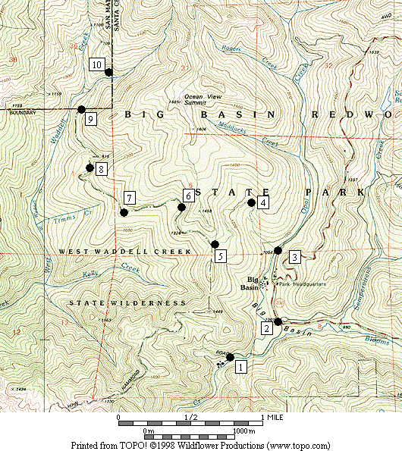

Figure 3-1. Stops on the Breeding Bird Survey route “Pescadero, CA” (#14-319) where Marbled Murrelets were detected on surveys in 1992-2007.

Figure 3-2. Marbled Murrelet activity recorded within Big Basin Redwoods State Park on the "Pescadero, CA” Breeding Bird Survey route in 1992 to 2007. (Note: No data for 2000; no detections in 2005.)

